Verify login with Invalid Data

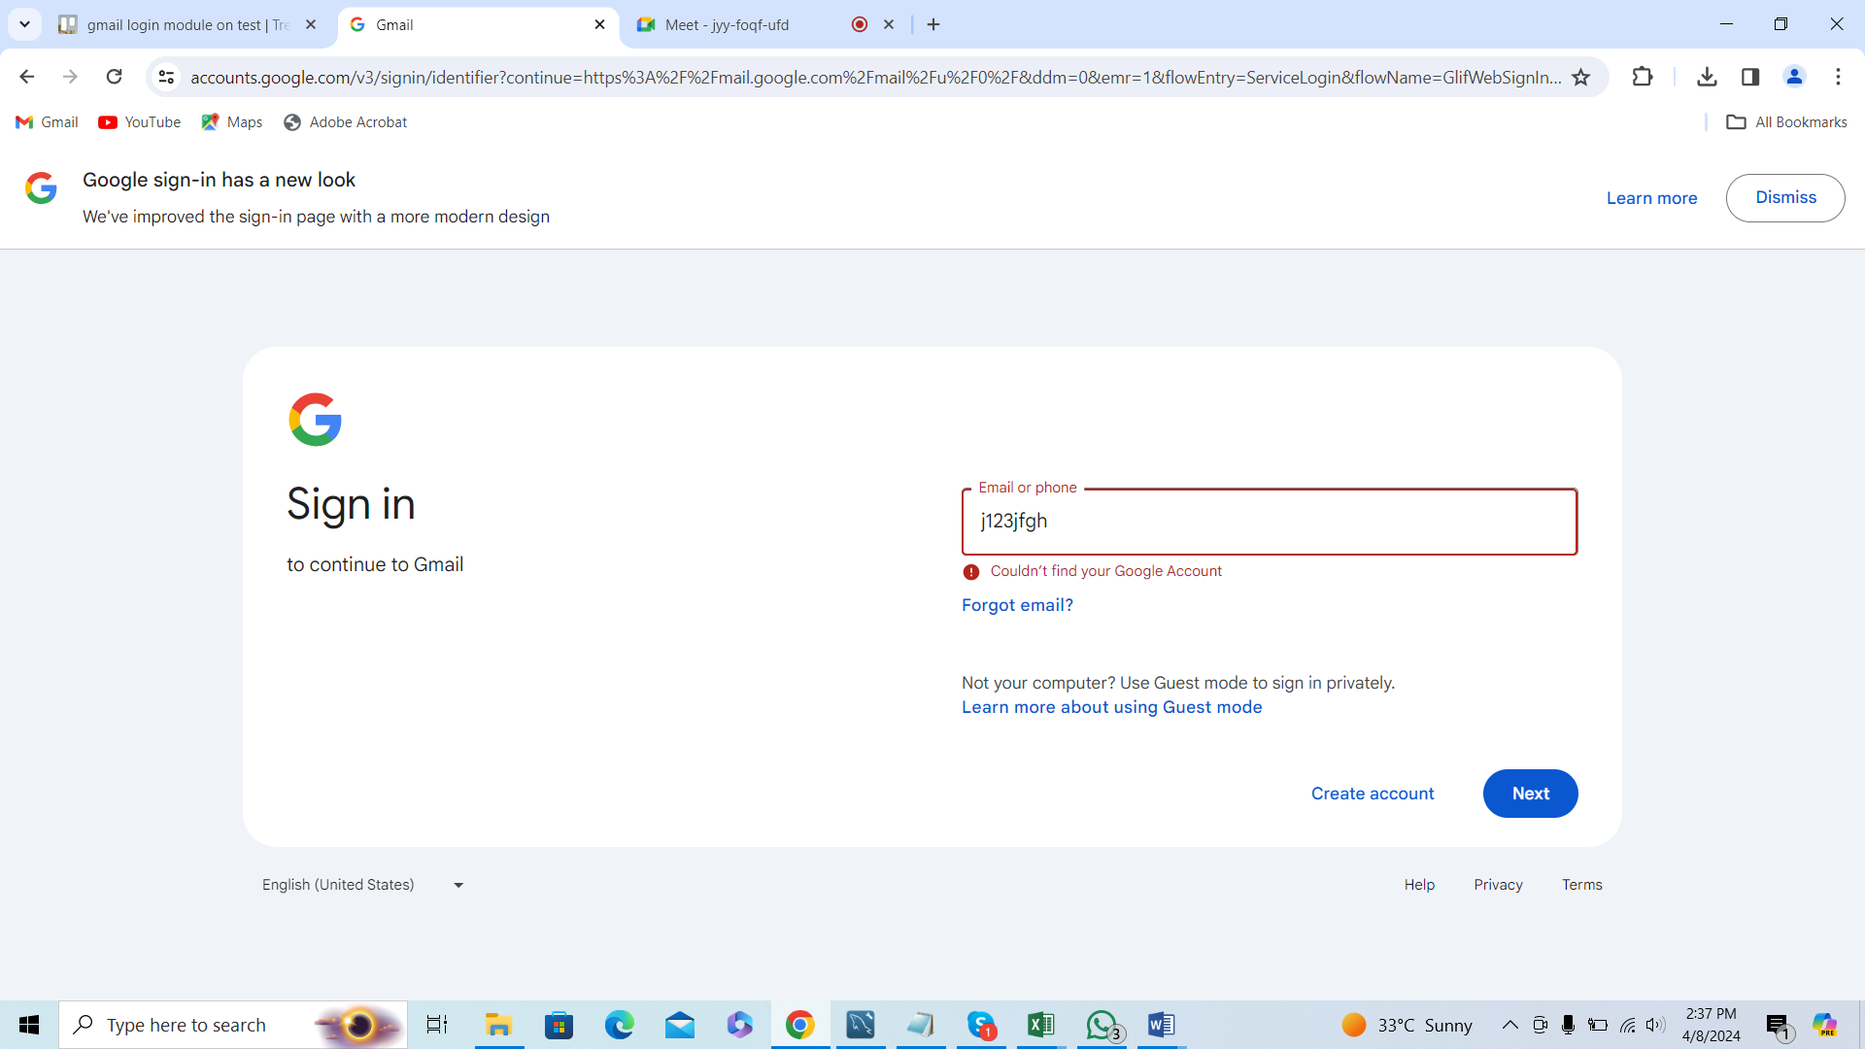

Error message is displayed